学术会议第二轮通知
“第三届世界天然药物和传统药物药理学学术会议”
2015年7月21-25日，新加坡

诚挚邀请
由国际药理学联合会（IUPHAR）天然药物药理学分会主办，新加坡国立大学、中国药理学会（CNPHARS）中药与天然药物药理专业委员会承办的“第三届世界天然药物和传统药物药理学学术会议”将于2015年7月21-25日在新加坡召开。会议网站请访问（www.pharmconf.org）。
本次会议主题是“药理学前沿在天然产物药物发现和发展中的应用”。学术交流形式包括大会报告、特邀报告、青年学者报告、壁报交流和学术研讨，内容涉及来源于天然和传统药物的新药发现、发展、基础与临床药理学研究。会议邀请IUPHAR领导、国际著名药理学家到会做学术报告并参与研讨，将为与会代表提供一次绝佳机会，进行天然药物和传统药物药理学研究成果、新思路、新方法、新技术展示、交流和学习。
我们代表会议组织方诚挚邀请全世界同行研究人员相聚在美丽的“花园之国”新加坡。相信本次会议将为促进国际交流与合作，推动天然药物和传统药物的药理学研究、新药研发的进步，作出巨大贡献。
欢迎参会、相聚狮城！
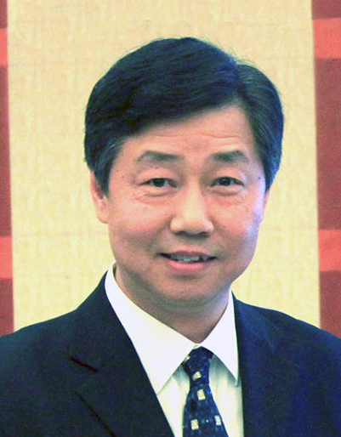
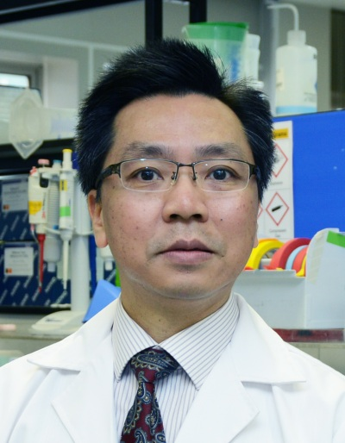

共同主席 共同主席
张永祥教授 Prof. WS Fred Wong

大会组织机构

主办单位
国际药理学联合会（IUPHAR）天然药物药理学分会(SPNP)


承办单位
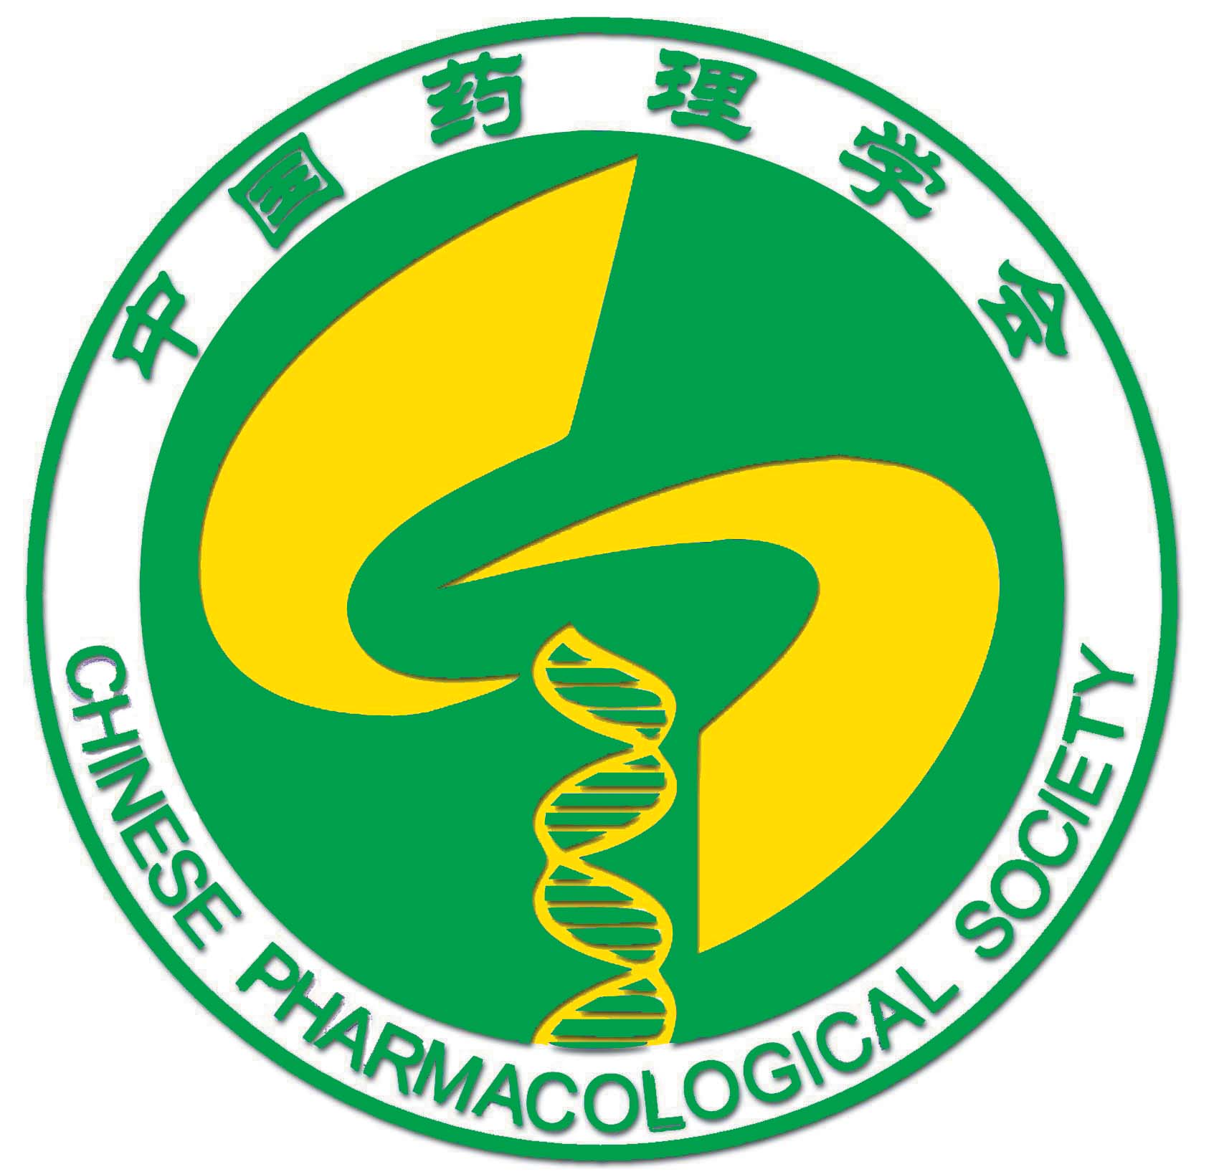
新加坡国立大学(NUS)
中国药理学会中药与天然药物药理专业委员会

组织委员会
共同主席
张永祥，北京药理毒理研究所教授，国际药理学联盟（IUPHAR）执行委员会委员，国际药理学联盟（IUPHAR）天然药物药理学分会（SPNP）主席，中国药理学会副理事长兼秘书长。
WS Fred Wong (黄玮韶)，新加坡国立大学杨璐琳医学院药理学系主任，国际药理学联盟天然药物药理学分会委员。
秘书长
杜冠华, 中国医学科学院北京协和医学院药物研究所教授，中国药理学会理事长。
副秘书长
Valérie Schini-Kerth，法国斯特拉斯堡大学教授，国际药理学联盟天然药物药理学分会副主席。
周文霞, 北京药理毒理研究所教授, 中国药理学会副秘书长。
Gavin Dawe, 新加坡国立大学杨潞龄医学院
成员
Ricky Y.K. Man, 香港大学教授，国际药理学会天然药物药理学分会委员、前主席。
林志彬，北京大学医学部教授，国际药理学联盟天然药物药理学分会委员，中国药理学会名誉理事长。
Thomas Efferth，德国美因茨大学教授，国际药理学会天然药物药理学分会委员。
Yasushi Ohizumi, 日本东北大学教授，国际药理学会天然药物药理学分会委员。
高秀梅, 天津中医药大学教授
胡刚, 南京医科大学教授
季宇彬, 哈尔滨商业大学教授
刘建勋, 中国中医科学院西苑医院教授
吕圭源，浙江中医药大学教授
孙晓波, 中国医学科学院北京协和医学院药用植物研究所教授
吴春福, 沈阳药科大学教授
萧伟, 江苏康缘药业股份有限公司
余林中, 南方医科大学教授
赵军宁, 四川省中医科学院教授

地区组织委员会
学术委员会
Gautam Sethi, Han-Ming Shen, Hwee-Ling Koh, Kathy Qian Luo, Chay Hoon Tan
公共委员会
Gavin Dawe, Matthew Chang, Qingsong Lin
运筹委员会
Mitchell Lai, Jinsong Bian
司库
Deron Herr
会议时间和地点
会议将于2015年7月21日-25日在新加坡国立大学Block MD6, Centre for Translational Meidcine (CeTM) 召开。
会议议题
1. Phytochemistry and Phytopharmaceuticals
2. Pre-clinical Pharmacology of Natural Product (NP) and Traditional Medicine (TM)
3. Clinical Pharmacology of NP and TM
4. Emerging Technology in Drug Development from NP and TM
初步日程如下，请关注会议网站更新信息（http://www.pharmconf.org/event-info/）
Agenda
July 21, 2015
Registration
July 22, 2015
Opening Ceremony 8:30 am– 9:00 am
Plenary Session 9:00 am – 9:45 am
Session I: Phytochemistry and Phytopharmaceuticals 9:45 am – 12:40 pm
Invited Lectures
Young Scientist Presentation
Lunch & Poster Session 12:40 pm – 1:40 pm
Plenary Session 1:40 pm – 2:30 pm
Session II: Pre-clinical Pharmacology of NP and TM I 2:30 pm – 6:00 pm
Invited Lectures
Young Scientist Presentation
July 23, 2015
Plenary Session 9:00 am – 9:45 am
Session III: Pre-clinical Pharmacology of NP and TM II 9:45 am – 12:40 pm
Invited Lectures
Young Scientist Presentation
Lunch & Poster Session 12:40 pm – 1:40 pm
Plenary Session 1:40 pm – 2:30 pm
Session IV: Clinical Pharmacology of NP and TM 2:30 pm – 6:00 pm
Invited Lectures
Young Scientist Presentation
July 24, 2015
Plenary Session 9:00 am – 9:45 am
Session V: Emerging Technology in Drug Development from NP and TM 9:45 am- 12:00 pm
Invited Lectures
Young Scientist Presentation
Closing Ceremony & Award Presentation 12:00 pm – 12:30 pm

新加坡国立大学地址：National University of Singapore, 14 Medical Drive, Singapore 117599
电话：+65 6516 3264
网址：http://www.nus.edu.sg/
会议邀请报告人
大会报告
Professor Jerold Chun, Department of Molecular and Cellular Neuroscience, The Scripps Research Institute, California, USA
Professor D. Darrel Duan, Center for Molecular Medicine, School of Medicine, University of Nevada, USA
Professor David Newman, Ex-Chief of Natural Product Branch, The Developmental Therapeutics Program, National Cancer Institute, Frederick, Maryland, USA
Professor Michael Spedding, Secretary General – IUPHAR, Outgoing Chair NC-IUPHAR, Spedding Research Solutions SARL, France
Professor Juntian Zhang, Institute of Materia Medica, Chinese Academy of Medical Sciences & Peking Union Medical College, Beijing, China

论坛报告
Matthew CHANG – Biochemistry, National University Singapore, Singapore
Li Lin Christina CHAI – Pharmacy, National University Singapore, Singapore
Ee Sin CHEN – Biochemistry, National University Singapore, Singapore
Chi Hin CHO – School of Biomedical Sciences, Chinese University of Hong Kong, Hong Kong, China
KS CHOI – Biochemistry and Molecular Biology, Ajou University, Korea
Marc DIEDERICH – College of Pharmacy, Seoul National University, Korea
Diadelis Remirez FIGUEREDO – Cuban Society of Pharmacology, Cuba
Ajay GOEL – Gastrointestinal Cancer Research & Epigenetics and Cancer Prevention, Baylor Research Institute, Baylor University, USA
Yi-Tsau HUANG – Chinese Medicine and Pharmacy, Ministry of Health and Welfare, Chinese Taipei
Kornkanok INGKANINAN – Naresuan University, Thailand
Jian-Dong JIANG – Institute of Materia Medica, Chinese Academy of Medical Sciences & Peking Union Medical College, China
Tapas KUNDU – Molecular Biology & Genetics Unit, JNCASR, India
Simon MY LEE – Institute of Chinese Medical Sciences, Macau University, Macau, China
Min LI – School of Chinese Medicine, Hong Kong Baptist University, Hong Kong, China
Shaoping LI –Institute of Chinese Medical Sciences, Macau University, Macau, China
Xue-Jun LI – Peking University Health Science Center, China
Albert WN LEUNG – School of Chinese Medicine, Chinese University of Hong Kong, Hong Kong, China
Qingsong LIN – Biological Sciences, National University Singapore, Singapore
Zhi-Bin Lin – Peking University Health Science Center, China
Kathy Qian LUO – Nanyang Technological University, Singapore
Ákos MÁTHÉ – International Council for Medicinal and Aromatic Plants, Hungary
Mohammad Rais MUSTAFA – University of Malaya, Malaysia
Gautam SETHI – Pharmacology, National University Singapore, Singapore
Valérie SCHINI-KERTH – Department of Pharmacology, University of Strasbourg, France
Han-Ming SHEN – Physiology, National University Singapore, Singapore
Lie-Fen SHYUR – Agricultural Biotechnology Research Center, Academia Sinica, Chinese Taipei
Johnson Stanslas – Universiti Putra Malaysia, Malaysia
Herry H SUN – Tasly Pharmaceuticals Inc., China
Haruki YAMADA – Kitasato University, Japan
Yu Leong YONG – Obstetrics and Gynaecology, National University Health System, Singapore
Wen-Xia ZHOU – Beijing Institute of Pharmacology and Toxicology, China
大会语言
大会学术交流语言为英语。不提供翻译服务。
交流方式
采取大会报告、特邀报告、青年科学家报告、壁报展示等多种形式进行交流。
征集论文摘要
- 征文截止日期：2015年4月30日
- 摘要要求及注意事项请参见网站(http://www.pharmconf.org/abstract/)。
- 会议论文在中国药理学会核心期刊《中国药理学与毒理学杂志》上刊登，摘要撰写要求及格式请参照附件1模板准备。
- 部分摘要将入选口头报告，其余以壁报的形式展出。壁报尺寸不超过为120 cm*80 cm

大会附设展览
欢迎医药相关的设备、仪器及药品等企业参加大会展览。
住宿
推荐宾馆信息请参加会议网站（http://www.pharmconf.org/accommodation/），参会人员可直接与希望入住的宾馆联系预订，亦可自行预订其他酒店。会议专为学生提供校园公寓住宿，价格低廉（约30新元/人/晚），环境舒适。如有需要，可发E-mail至pharmconf@nuhs.edu.sg预订。
注册及缴费
会议采用在线注册和缴费，注册指南请参见会议网站（http://www.pharmconf.org/register/）。
注册费：参会代表注册费收取标准请参加会议网站（http://www.pharmconf.org/register/）.
 | 注册费（新加坡元）
 | 2015年3月15日前 | 2015年3月15日  --6月30日 | 2015年6月30日后
正式代表 | 200 | 250 | 300
学生 | 100 | 150 | 200

联系方式
新加坡国立大学
A/Prof Wong Wai-Shiu, Fred
Department of Pharmacology,
Yong Loo Lin School of Medicine,
Blk MD11, CRC, Level 5, #05-09,
10 Medical Drive,
Singapore 117597
Tel: +65-6516 3264
E-mail: pharmconf@nuhs.edu.sg
中国药理学会
赵颖博士
地址：北京市西城区先农坛街1号，中国药理学会办公室，100050
电话/传真：+86(10)63165211
E-mail: cnphars@163.com

附件1 Abstract template for the IUPHAR World Conference on Pharmacology of Natural and Traditional Medicine 2015

The abstract should be written as follows:
- Title should concisely and accurately reflect the content of the articles. No subtitles should be used. Not more than 200 characters.
- Authors should be the contributors who can answer the questions relevant to the articles. The writing order is first name followed by the family name (family name in capital letters). The participant may be the first presenting author of one abstract, however, a participant may be second or subsequent author of other abstracts. The Chinese author names should be in Pinyin (such as: Guang-hui YANG, Gang LI).
- Affiliations and their full mailing addresses (city, postal code and country or region) should be listed beneath the authors. Affiliations should be in their full names, including the specific sections. If the authors are from different affiliations, numbers such as “1” and “2” should be inserted to the upper right corner of the authors’ names in superscript as well as before the affiliations.
- Abstract should be written in a structured abstract format, indicating the OBJECTIVE, METHODS, RESULTS (key data should be presented instead of merely summarizing the main findings), and CONCLUSION. Use 12-point Times New Roman, 1.5 line spacing, and Word format, no more than 2,000 characters including spaces. Use standard abbreviations for units of measure. Other abbreviations should be spelled out in full at the first mention, followed by the abbreviation in parentheses.
- Key words about three to eight, separated by semicolons (;), should be listed after the abstract.
- Other information should be placed at the end of the abstract, including the source and the number of your fund; and the name and E-mail address of the corresponding author.

Address：Editorial Office of Chinese Journal of Pharmacology and Toxicology, 27 Taiping Road, Beijing 100850, China
Telephone：010-66931617, 010-68276743
E-mail：cjpt@bmi.ac.cn Website : http://www.cjpt.ac.cn
Contact: QI Chun-hui
Example：
Effect of YL-0919, a new antidepressant candidate, on behavior and hippocampal dendritic complexity of chronically stressed rats

Hui XIA^{1,2}, Yan-qin LIU ¹, Rui XUE ¹, Zhen-zhen WANG ³, Nan ZHAO ¹, Li-ming ZHANG¹,Ri-fang YANG ¹, Hong-xia CHEN ¹, Yun-feng LI ¹
(1.Institute of Pharmacology and Toxicology，Academy of Military Medical Sciences, Beijing 100850, China; 2. 302 Hospital of People’s Liberation Army, Beijing 100039, China; 3. Chinese Academy of Medical Sciences and Peking Union Medical College, Beijing 100050, China）

OBJECTIVE To investigate the effect on anti-depression and dendritic complexity of YL-0919, a novel dual acting antidepressant with 5-HT_{1A} receptor agonist and serotonin reuptake inhibitor properties. METHODS To apply the chronic unpredicted stress (CUS) model in rats, the rats were subjected to 1-2 stressors randomly chosen from 10 different stressors except for control non-stressed group. The vehicle or YL-0919 (0.625, 1.25 or 2.5 mg·kg⁻¹) or fluoxetine (10 mg·kg⁻¹) was administered orally 1 h before the stress procedure. After 4-week stress, the open field test (OFT), sucrose preference test, and novelty suppressed feeding (NSF) test were performed to evaluate the changes in behavior. Golgi staining was applied to evaluate the changes in dendritic length, branching points and spine density of the hippocampus pyramidal neurons. RESULTS The locomotor activity and sucrose preference of chronically stressed rats were significantly decreased, but the latency to NSF was increased, while administration of fluoxetine (10 mg·kg⁻¹, ig) and YL-0919 (2.5 or 1.25 mg·kg⁻¹, ig) reversed those effects. Golgi staining showed that YL-0919 increased dendritic complexity. After administration of YL-0919 (2.5 or 1.25 mg·kg⁻¹, ig) and fluoxetine (10 mg·kg⁻¹, ig), the total dendritic length was increased by 24.3%, 64.7% and 76.0%（P＜0.01), respectively, while the number of dendritic branching points was increased by 38.0%, 118.2% and 109.1%（P＜0.01), respectively. After administration of YL-0919 (2.5 mg·kg⁻¹, ig) and fluoxetine (10 mg·kg⁻¹, ig), dendritic spine density was increased by 20.5% and 21.4% (P＜0.05). Chronic treatment with YL-0919 increased dendritic complexity significantly. CONCLUSION YL-0919 produces reliable antidepressive effect on the chronically stressed rat models. The dendritic complexity of hippocampus pyramidal neurons contributes to the pathophysiology of depression, and the antidepressionlike effect of YL-0919 may be related to the protection of neurons.
Key words: YL-0919; depression; stress disorders, posttraumatic; behavior; hippocampus; dendrite

Foundation item: The project supported by National Natural Science Foundation of China(81102423); National Natural Science Foundation of China(81001653); and National Natural Science Foundation of China(81173036)
Corresponding author: Yun-feng LI, E-mail: lyf619@aliyun.com, Tel: (010)66930650

